**Steps for how to create CLR Stored Procedure – SQL Server**

**What is CLR?**

The .NET Framework provides a run-time environment called the common language runtime (CLR). CLR manages the execution of programs written in different supported languages.

CLR transforms source code into a form of bytecode known as Common Intermediate Language (CIL). At run time, CLR handles the execution of the CIL code.

For further reading on CLR, please go through the article provided in below link:

<https://docs.microsoft.com/en-us/dotnet/standard/clr>

**CLR Role in SQL Server Stored Procedure:**

CLR plays the role of interoperability to make C# code being worked as SQL Stored procedure.

To make the C# code to be understandable or converted to SQL Stored procedure, CLR comes into picture.

The reason to create Stored Procedure or Functions in CLR is to accomplish many tasks which is not possible in T-SQL like complex String Operations etc. So, without further due let’s get started.

In this example, we will be printing the Current System Date in the CLR Stored procedure.

**Step 1:** Enable CLR by executing the below scripts in SQL Server:

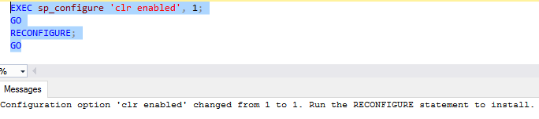

**Step 2:** Create a SQL Server Database Project with the same name as Database Name under which you want to create CLR Stored Procedure. Please find below snippet for your reference:

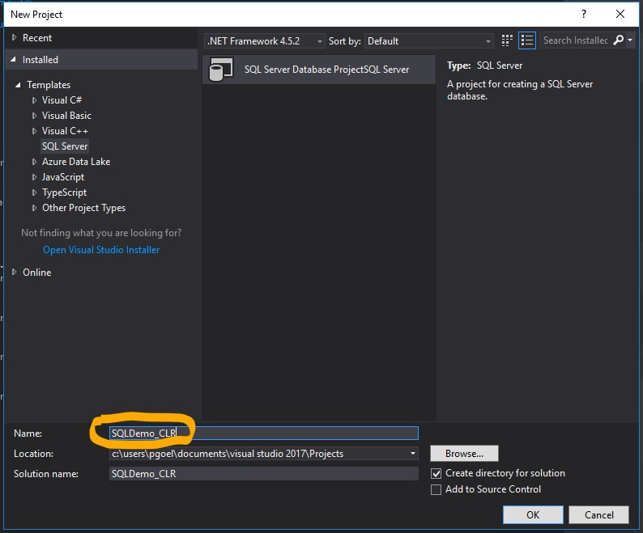

Highlighted Name is same as Database Name already present in SQL Server.

Step 3: Once the project is created. Import the mentioned database in this project by clicking on database option in below snippet:

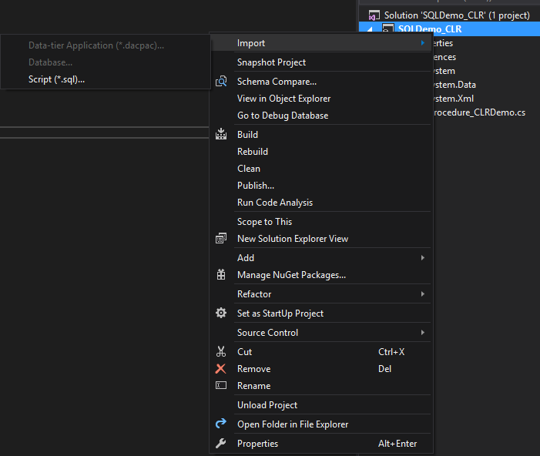

Next Step is to provide the Database details for which you want to do the import.

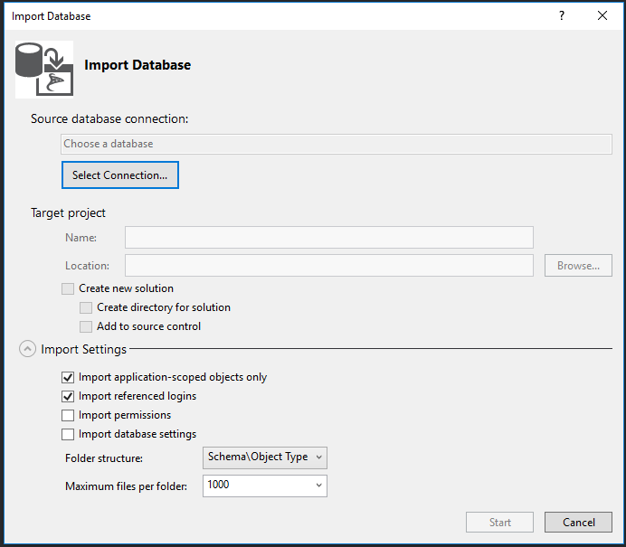

After clicking on ‘Select Connection’, you will see the below pop up where you should select the Database:

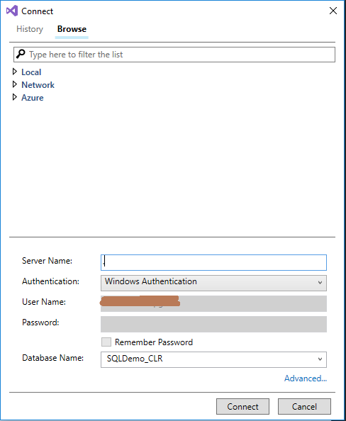

Once you provided the details for Server and Database, click ‘Connect’ 🡪 then click ‘Start’ button from previous snippet. This will start importing the Database to your project.

Step 4: Now you imported the Database to your project, it’s time to add a C# Stored Procedure definition. Follow below steps to add CLR C# Stored Procedure.

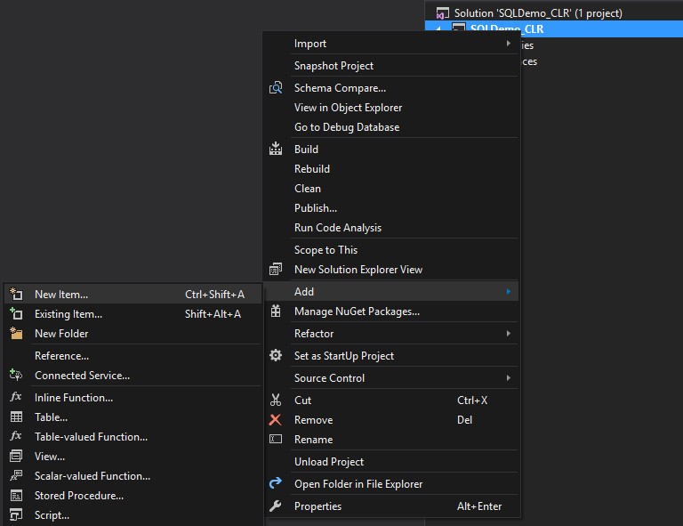

You need to select SQL CLR C# Stored Procedure and provide some meaningful name.

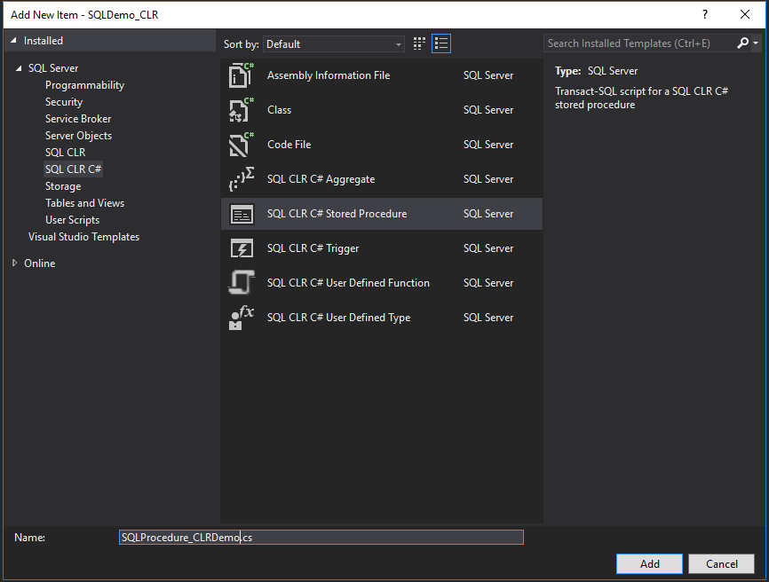

Once the file is added for SQL CLR C# Stored Procedure. Please update the code as mentioned below and save the file:

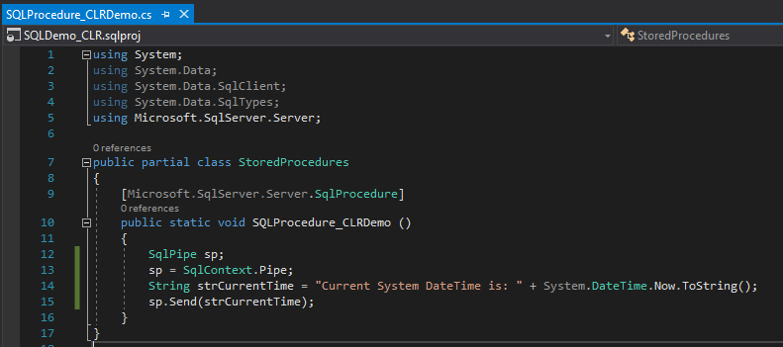

Step 5: Now right click the solution and click ‘Build Solution’ option to build the created solution.

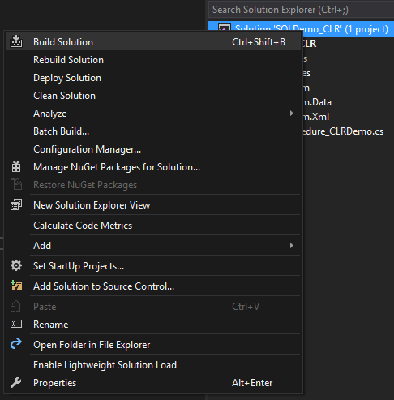

Once the build is succeeded, ‘.dll’ file will be created under your project folder on your disk as shown in below snippet.

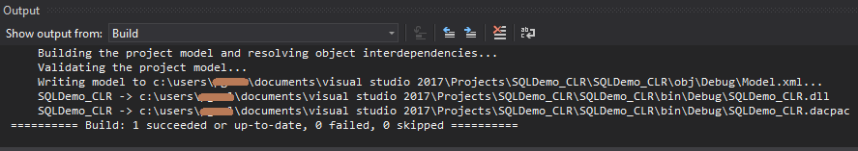

Step 6: Now after .dll file is generated, there are two options to deploy the CLR Stored Procedure in SQL Server. Let’s talk about Case 1 first.

CASE 1: Publish the database.

We need to publish the project to the respective database.

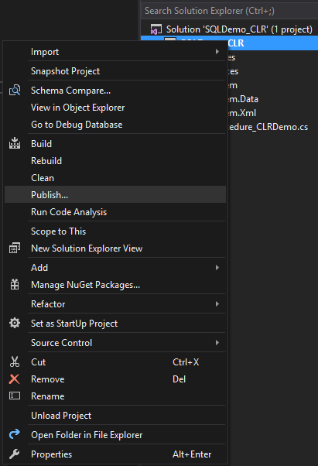

Once you click the above option, below pop up will ask to provide the database connection to publish the Project.

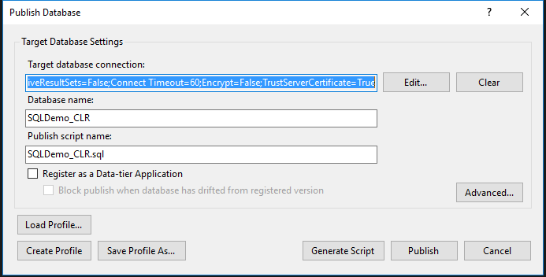

After you provided the required information, click on publish and you should see the below output.

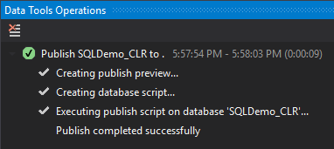

This is the Case 1 to deploy the CLR Stored Procedure in SQL Server. Now if you will check in your SQL Server database, CLR Stored Procedure should be visible.

CASE 2: Manual Process

Create an Assembly: Use the generated .dll file for creating assembly. Execute the below script by providing the values in place holders in SQL Server to create Assembly corresponding to .dll file.

CREATE ASSEMBLY [SQLDemo_CLR]

FROM '<<path of the .dll file generated to be provided by us>>'

WITH PERMISSION_SET = SAFE

GO

Create a SQL Server CLR Stored Procedure from the Assembly by executing below query:

CREATE PROCEDURE <<Procedure Name to be provided by you>>

AS

EXTERNAL NAME SQLDemo_CLR.StoredProcedures.SQLProcedure_CLRDemo

GO

This is CASE 2 to manually deploy CLR Stored Procedure in SQL Server. And when you will execute the created procedure in either of the CASE, you should see the below result.

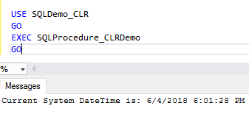

NOTE:

1. Stored Procedure Name will always be same as Function name in CLR C# code for Stored Procedure in CASE 1 of the deployment. But you can have different Stored Procedure name in CASE 2 of the deployment.